Profile

1. Name : RAYAVARAPU NAGA SRINIVASU

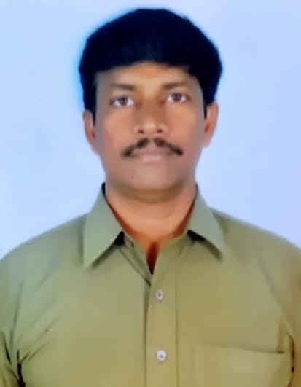

1. Designation : Lecturer in Commerce
2. Date of Birth : 15.06.1974
3. Educational Qualifications : M.Com, PGDCS
4. Teaching experience : 15 Years
5. Research Experience : NIL
6. Dissertation/Thesis Title : NIL
7. No. of Research publications : NIL
8. No. of Books Published : NIL
9. No. of Major/Minor Research Projects: NIL
10. Title of Minor Research Project : NIL
11. No .of International Conferences Attended : NIL
12. No. of National Conferences Attended : NIL
13. No. of Papers Presented at the Seminars/Conferences: NIL
14. Refresher Courses/Orientation Programs/Training Programs Attended: NIL
15. Vidwaan Score : NIL
16. Address : R.N. SRINIVASU,

Opp. To Bhavni Type Institute,

Javvadi Street

PENUGONDA-534 320; W.G.Dt.

1. E-mail Id : vasurns@gmail.com
2. Contact no : 9440467322